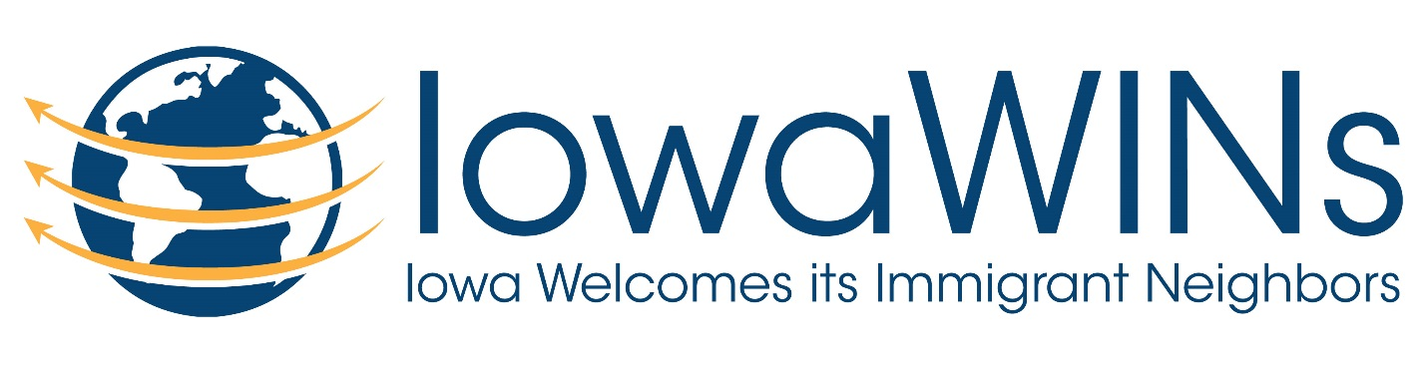

Iowa WINS (Iowa Welcomes Immigrant Neighbors)
Refugee and Immigrant Assistance Commission
Wednesday, February 7th at 7:00 PM
First Presbyterian Church
902 S. Walnut St
Mt. Pleasant, IA 52641

OUR VISION:
That the greater Mount Pleasant community would be an inclusive and hospitable community that welcomes people from across the world looking for a new home.
In order to achieve that vision, the MISSION OF IowaWINs is to:
- Identify the issues that newcomers face here, to provide solutions and help integrate them with the community at large.
- Build relationships among the diverse members of our community.
- Build and maintain the infrastructures and sustainable programs that improve opportunity and services now and for future generations of immigrants.
- Provide educational and cultural outlets to the community to learn more about the people (and their needs) who come to Mount Pleasant.
Agenda
- Introductions
- Cryptocurrency and how it can be used to directly support refugees in other countries.
- Citizenship tutoring
- Government Actions – talk to your legislators
  - Removing TPS (temporary protected status) for Hondurans and El Salvadorans
  - DACA (Deferred Action for Childhood Arrivals)
  - Response from the Iowa Commission of Latino Affairs on TPS and DACA https://humanrights.iowa.gov/sites/default/files/media/Iowa%20Commission%20of%20Latino%20Affairs%20Letter%20to%20Congress%20about%20DACA%20and%20TPS_2018.pdf?utm_medium=email&utm_source=govdelivery
  - Iowa legislation: The anti-immigrant, warrantless detention bill, SF 481 is a bill for an act relating to the enforcement of immigration laws and providing penalties and remedies, including the denial of state funds to certain entities. (Formerly SSB 1172.)
  - Information from AFSC on SF 481 and two pro-immigrant resolutions: https://drive.google.com/drive/folders/1i19LAfbXfbUZ3As4Hcc7vl6fhuTmJJ-w
  - Update from Dina on conversations with Rep Heaton and Rep Taylor at 1/27 town hall.
  - Next Legislator Town Hall is Saturday, February 24 at 8:30 at IWU

Immigration 202: Immigration in Iowa – Program in Des Moines – Carpool???
Interested in taking your knowledge about U.S. immigration to the next level? Looking for answers to pressing questions? Join local experts and community members as they present their experiences, stories, overview of immigration laws and lead a discussion to answer your most pressing questions. Advocates will also discuss ways Iowans are getting involved in working to advance immigrants’ rights in cities and congregations across the state.
  - Saturday, February 24th, 9:00am-1:00pm
  - First Unitarian Church of Des Moines
  - (1800 Bell Ave. Des Moines)

- Local Winter Educational events
  - Vietnam War - The Chadwick Library at Iowa Wesleyan University in partnership with the Mount Pleasant Public Library will feature Ken Burns & Lynn Novick’s Vietnam War. The two libraries will host showings of the documentary for five weeks each Sunday and Monday in the International Room of the Chadwick Library at Iowa Wesleyan University at 7:00 pm
- January 28-29
- February 4-5
- February 11-12
- February 18-19
- February 25-26
- Tuesday, February 27 | 7:00 p.m. | International Room, Chadwick
A panel discussion about the documentary featuring Iowan and Former Ambassador to the Kingdom of Cambodia, Dr. Kenneth M. Quinn.
- Bystander Intervention Training Tammy attended a webinar in November by AFS (American Friends Society) on how to intervene in public instances of hate speech including racist, anti-Black, anti-Muslim, anti-Trans, and other forms of oppressive interpersonal violence and harassment while considering the safety of all parties. It can be one tool on the way towards building strong communities that resist institutionalized racism and violence.
    - Jeff and Tammy met with two IW instructors and we are planning to offer this training during two class periods in two separate classes in April.
      - Wednesday, April 4th at 10
      - Friday, April 6th at 11
      - Monday April 9th at 10 and 11
    - Please let me know if you would be interested in attending or participating as a facilitator.
    - Dina will check on opportunities to use the training with the school district
  - International Potluck at IW - Sunday, April 8, 5:00 p.m., Social Hall in the Student Center
    - Publicity
    - Food
    - Logistics
    - Connect with Johney Thiengmany from the Laos Association
  - Scholar in Residence – Beth Howard of our group had suggested that Pastor John Pavlovitz (https://johnpavlovitz.com/) who recently wrote a book called A Bigger Table about building community might be available for a speaking event.
  - Genesis of Exodus – This film is now available for public viewing. We discussed holding the event at the local theatre but also discussed holding it at the International Room in the Chadwick Library where it would be easier to hold discussion after the film. Sam Riepe was unable to attend but volunteered to coordinate dates for the film with the theatre and to obtain the DVD.
    - The Genesis of Exodus: The Roots of Central American Migration
    - Link to trailer: http://storymap.genesisofexodusfilm.com/index.html
    - Link to film: https://genesisofexodusfilm.com/
    - Link to resources: https://genesisofexodusfilm.com/resources/
  - Two other shorter films could be used in conjunction with a meal or meeting. Possibly trying a noon time option to reach different people. We can discuss ideas and timing to use these films at our next meeting. Possible good options for speaking engagements.
    - To Breathe Free
      - Short documentary and winner of "Best Documentary Short" at the Covellite International Film Festival 2017: "Give me your tired, your poor, your huddled masses yearning to breathe free.” To Breathe Free follows the 5-year journey of a Syrian family fleeing the war in Homs to the refugee camps in Jordan and starting a new life in Washington, D.C.
      - https://vimeo.com/225871896
    - Locked in a Box
      - “Locked in a Box” is an award winning short documentary that follows the stories of individuals held in the U.S. Immigration detention system and those who visit them. The film traces the lives of individuals who fled their homelands in search of safety and freedom only to end up in U.S. prisons under a mandatory bed quota system run by Immigration Customs & Enforcement.
      - https://vimeo.com/145351153
  - Refugee Simulation – Joy Lapp has engaged her students in holding an IW event that would also be open to the public using the simulation materials that Emily Situmeang developed. Possible date is Sunday, April 15th.

- PCUSA resources on fighting racism and immigration advocacy
  - https://facing-racism.pcusa.org/
  - pcusa.org/advocacytraining

- Thanks to Johanna who saw a recent replay of this program on the Syrian humanitarian crisis: 2017 Whitney Reynolds Show – 26 minutes. The very last segment includes an interview with Becky Carroll who has started a Facebook group #standwithaleppo
  - https://www.youtube.com/watch?v=WOMp0AVxcAU&feature=youtu.be&list=PLmk__d_gEap0b5cvNARI99BGK4q58wUnH
- IW International Conversation Café – Fred Miller shared information about a biweekly opportunity for international students and community members to interact with discussion and games while enjoying dessert. The focus is to connect the community and the international students as well as giving the students the opportunity to practice their English skills. Feel free to attend any or all of the remaining café events at the Tiger Den in the Student Union)
  - Thursday, February 8th from 7 to 8 PM
  - Thursday, February 22nd from 7 to 8 PM
  - Thursday, March 8th from 7 to 8 PM
  - Thursday, March 22nd from 7 to 8 PM
  - Thursday, April 5th from 7 to 8 PM
  - Thursday, April 19th from 7 to 8 PM

Look forward to seeing you on Wednesday!

Thanks,
Tammy Shull
tammyshull@windstream.net

