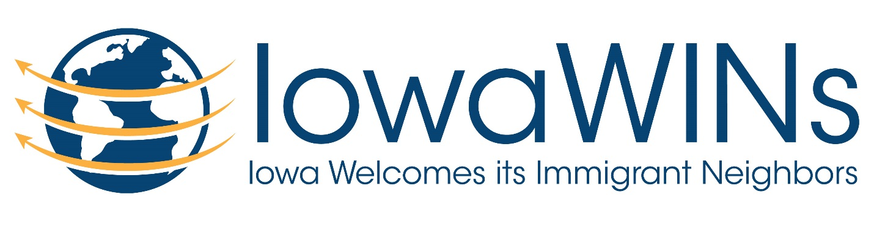

Iowa WINS (Iowa Welcomes Immigrant Neighbors)
Refugee and Immigrant Assistance Commission
Wednesday, June 6th at 7:00 PM
First Presbyterian Church
902 S. Walnut St
Mt. Pleasant, IA 52641

OUR VISION:
That the greater Mount Pleasant community would be an inclusive and hospitable community that welcomes people from across the world looking for a new home.
In order to achieve that vision, the MISSION OF IowaWINs is to:
- Identify the issues that newcomers face here, to provide solutions and help integrate them with the community at large.
- Build relationships among the diverse members of our community.
- Build and maintain the infrastructures and sustainable programs that improve opportunity and services now and for future generations of immigrants.
- Provide educational and cultural outlets to the community to learn more about the people (and their needs) who come to Mount Pleasant.
Agenda
- Introductions
- Update on status of immigrant men detained by ICE and their families
- Reports from sub-teams on the following issues
- Family support/School support/Transportation
- Event planning
- Media/Social Media
- Governmental contacts
- Fundraising
- Donations – collection and distribution
- Financial tracking

Look forward to seeing you on Wednesday, June 6th!

Thanks,
Tammy Shull
tammyshull@windstream.net

